Chapter 12, Solution 6.

Using Fig. 12.41, design a problem to help other students to better understand balanced wye-wye connected circuits.

Although there are many ways to work this problem, this is an example based on the same kind of problem asked in the third edition.

Problem

For the Y-Y circuit of Fig. 12.41, find the line currents, the line\ voltages, and the load voltages.

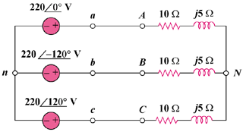

Figure 12.41

Solution
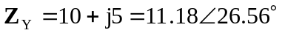

The line currents are
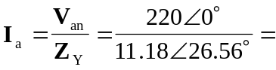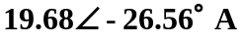
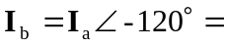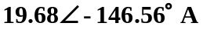
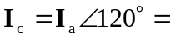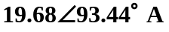

The line voltages are
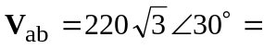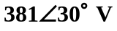
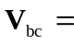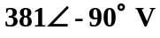
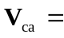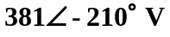

The load voltages are
